No internet connection when 4G LTE router in 4G mode with SIM card inserted

First we need to confirm the 4G LTE router’s WAN IP address exist or not (By Mobile Device: run any browser APP and input http://tendawifi.com into search bar and visit while connecting to the WIFI signal generated by the 4G LTE router.)

Situation 1: The WAN IP address do not exist.
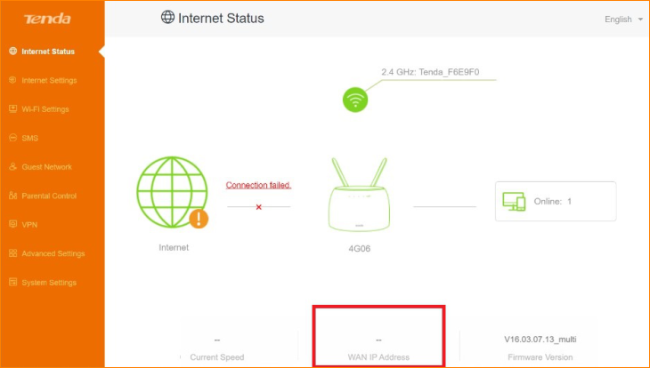

Possibility 1: SIM card is locked.

Solution: If router’s management page shows “Please unlock the SIM card”, you have to contact internet service provider to get PIN code, and enter the following path: Advanced Settings-> SIM PIN, input the PIN code to unlock the SIM card.

Possibility 2: APN information do not match or correct APN information not be recognized.

Solution: You have to collect SIM card APN information first by call the internet service provider or using an Android system phone (using Android system phone collect APN information you can refer to this link: https://youtu.be/N6LXeljdP3c ).
After getting needed APN information, go “Internet Settings” option page and click “Create a Profile” button. fill them into the router (detail steps can refer to this link: https://youtu.be/zbHpVTi4msw )

Possibility 3: SIM card function abnormal.

Solution: Insert the SIM card into the phone check it can whether be used, if it’s status abnormal please contact corresponding internet service provider for help.

Possibility 4: Network signal weak

Solution: Adjusting the extender antennas make it fixed sturdy. You could also move the router’s position to a properly place to get better signal.

Situation 2: The WAN IP address exist.

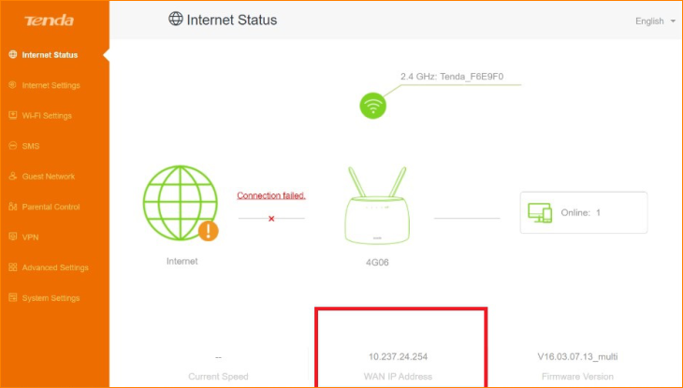

Possibility 1: SIM card owe the fee or do not have data

Solution: Contact internet service provider to confirm SIM card current status.

Possibility 2: Data usage reach the limitation.

Solution: Enter the following path: Advanced Settings -> Mobile Date. Turn off “Mobile Date” function, or set a higher allowance.

If you encountered other situations not described above, please update your router’s firmware or contact our tech support by send E-mail to support@tenda.com.cn.

